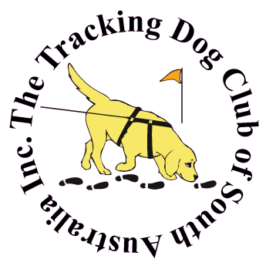
The Tracking Dog Club of S.A. Inc.

Application for Membership

or

Renewal of Membership
for 1st Nov 2023 to 31st Oct 2024

PLEASE PRINT CLEARLY
Joining Fee: $10.00 Single Membership $20.00 Family Membership $25.00

Name(s) (Mr /Mrs / Ms) ............................................................................................................................................................

Address: ...................................................................................................................................................................................

....................................................................................................... Post Code: .....................................................................

Telephone No. Home: ................................................................. Mobile: ............................................................................

Email Address: ..........................................................................................................................................................................

SACA Member No: ..................................................................... Date (To-days) ...............................................................

Name of Dog(s) | Pet Name | Breed: | Date of Birth | Sex
.................................................................... | ............................... | .......................................... | ............................ | ............
.................................................................... | ............................... | .......................................... | ............................ | ............
.................................................................... | ............................... | .......................................... | ............................ | ............
.................................................................... | ............................... | .......................................... | ............................ | ............
.................................................................... | ............................... | .......................................... | ............................ | ............
I/We hereby agree to observe and perform and in all aspects to conform to and be bound by the Constitution and Regulations of The Tracking Dog Club of S.A. Inc.

I/We indemnify The Tracking Dog Club of S.A. Inc. against any claim for damages to personal injury however caused.

Signature(s) ......................................................................................................................................

Membership includes Electronic copy of Tracksure magazine.
Give this form to: The Treasurer, Linda Castle
Mob: 0412 845 030 email: l_castle@optusnet.com.au
Bank Transfer available BSB 105-034 Account 155 215 740 must Include full name on transfer
Membership not valid without payment AND a Form

